Prioritisation of Projects with ICT Involvement

Oxford, 31st July 2023

Rocco Labellarte, Chief Technology and Information Officer (CTIO)

Contents
Executive Summary 1
Background and Context 2
Challenges to Successful Delivery 3
Recommendations 4
Next Steps 5
Appendix 1 – Prioritised Projects by Starting Quarter 5
Appendix 2 – Projects by ICT Team and Priority 13
Appendix 3 – Projects with an impact on ODS 16
Appendix 4 – Projects with no start date identified 17
Appendix 5 Projects with funding not identified 19
Appendix 6 – Criteria for differentiation small pieces of work from projects 22

Executive Summary

This document provides the Corporate Management Team and Audit Committee with a high-level update on the progress of reviewing the 120+ projects involving ICT across the Council and its companies.
The purpose of the review is to get agreement from Service Areas on the following:
- the relative priority of projects by individual Service Area (high, medium, or low).
- the timeline for each project, adjusting where possible to manage capacity and highlighting when and where demand exceeds resource capacity.
- the governance by which projects are accepted and prioritised on the work plan.
The projects have been compiled into a database which shows the relative priorities (see Appendix 1) and draft timelines for delivery (see Appendix 2), to be confirmed with Service Areas. The projects with an impact or involvement of ODS are shown in Appendix 3. For the avoidance of doubt, the criteria for differentiation small pieces of work from projects are listed in Appendix 6.
The recommendations for consideration and agreeing or noting by CMT are the following:
- All new proposals with a clearly defined scope must first go through the Organisational Change Board (OCB) using the existing Front Door of Change process.
- Before being presented to OCB, the proposal must be reviewed by ICT, including the proposed prioritisation against the work plan.
- The chair of the OCB has delegated authority from CMT to make the final decision on whether to proceed with the proposal, the relative priority, and the timeline for delivery.
- Where demand exceeds organisational capacity, a decision must be taken by OCB whether to delay one or more proposals or require further capital investment to provide additional resources for the duration of the project.

- Proposals cannot proceed to the procurement or delivery stages without agreed-upon means of funding the project and ongoing operational licensing and support, to be noted on the prioritised project work plan.

Background and Context

In June 2023, the Chief Technology and Information Officer (CTIO) met with colleagues from OCC, ODS, and OX Place (listed below) to produce a unified list of ICT-related projects. For each Service Area, relative priorities (High, Medium, Low) were assigned to each project.
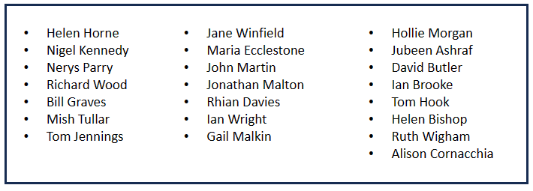
Table 1 – OCC, ODS, and OX Place colleagues engaged in the prioritisation process.
The information was gathered and organised into a database, including details of preferred timelines, statuses, and relative priorities. The database includes 120+ projects. The distribution by Service Area spread is listed below:
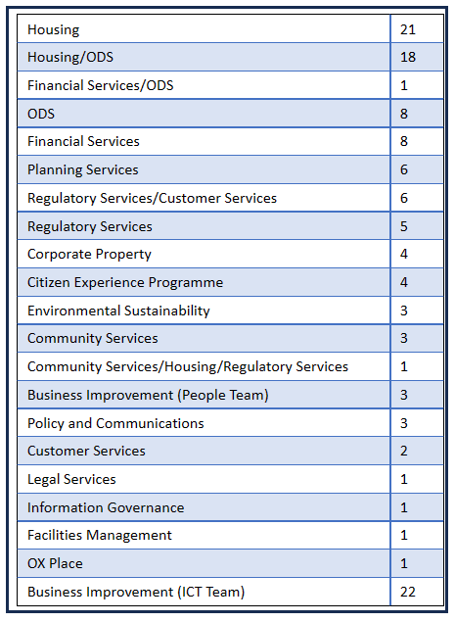
Table 2 – Summary of the projects identified in each Service Area

Challenges to Successful Delivery

The projects have been arranged in priority order, quarter by quarter (see Appendix 1). All projects are deemed deliverable from an ICT perspective, with the caveats noted below. Projects added will require amending the timeline to avoid delays to already planned projects.
In addition to the need to establish a Front Door of Change prioritisation process, the following caveats to the timely delivery of the projects on the work plan have also been identified:
- Individuals who possess unique skills within the Council. Increasing resources could be considered on a permanent (revenue) or time-limited (capital) basis. The same resources across Service Areas are often called upon to deliver projects.
- As an alternative to additional funding, the timelines for project delivery should be reviewed to reduce pressure on staff in certain areas. Examples include the Housing/QL program comprising 40+ projects, 18 requiring Network and Telecommunications skills, and 60+ online forms needing development.
- The timely progression of non-ICT stages, such as requirements gathering and procurement, is important. Delays in these stages reduce the time available to carry out the work, posing challenges to timely delivery.
- Addressing projects that sidestep the Front Door of Change is crucial to ensure alignment with the overall project prioritisation process. For example, until recently, ODS did not subscribe to the Front Door of Change. That is changing as a result of the work carried out in recent weeks.
- Over 120 projects with ICT involvement are scheduled for delivery in the financial year and beyond, many without a clear funding stream. Expectations on the capacity of the organisation to manage change need to be set.

Recommendations

To support the effective implementation of the prioritisation process, we ask CMT to support the following recommendation:

All projects should adhere to the governance outlined below. No project should be permitted to advance without complying with the following guidelines.
- Front Door of Change: Projects should adhere to the existing process, initially requiring them to be presented to the Organisational Change Board (OCB).
- Collaborative Prioritisation: Before the OCB presentation, the Service Area responsible for the project should work closely with the ICT department to prioritise the project with all other projects.
- OCB Review: The OCB should review and either approve or modify the project's prioritisation and timeline for delivery, with the delegated authority granted by CMT to the chair of the OCB to make the final decision on these specific matters.
- Resource Allocation: If necessary, other projects should be pushed back to ensure there is sufficient organisational capacity to deliver the new project.
- Scope Management: Projects must have a well-defined scope, and any changes to the scope before, during, or after project delivery should be approved through the OCB.
- Capital and Revenue Funding: Projects should only proceed once the capital and revenue funding has been agreed upon.

Next Steps

Establishing corporate prioritisation is key to effectively delivering the many projects involving ICT. Our proposed solutions are designed to streamline the process, foster better collaboration between Service Areas and the ICT department, and ensure optimal allocation of resources. Implementing these guidelines will improve project outcomes and enhance delivery timelines.
- The next steps entail sharing and reviewing the prioritised list with the Heads of Service to reach a consensus on the overall forward plan. This is underway at the time of preparing this report and should be completed by the end of August 2023.
- Subsequently, no projects will be permitted to proceed without following the process through the Organisational Change Board.
- ICT will regularly monitor project prioritisation to identify areas for further improvement.
By adopting these measures, the Council will improve its project delivery capabilities and optimise resource utilisation, ultimately contributing to successfully delivering the most important projects.
Appendix 1 – Prioritised Projects by Starting Quarter (Page 1)
Ref | Project ID | Project Stage | Business Owner(s) | Status | Priority | Starts in Quarter | Due Date
1 | Fixed Line and Mobile Telephony Replacements | 10 Project Delivery | ICT | In Delivery | 01 - High | Q2-22 | 30/07/2023
2 | Microsoft 365 Migration & OneDrive & Desktop 365 | 10 Project Delivery | ICT | In Delivery | 01 - High | Q2-22 | 28/12/2023
3 | Local Land Charges | 10 Project Delivery | Planning | In Delivery | 02 - Med | Q2-22 | 24/08/2023
4 | Data Centre Savings Initiatives | 10 Project Delivery | ICT | In Progress | 03 - Low | Q2-22 | 31/03/2024
5 | Uniform/IDOX Replacement | 06 Procurement | Planning | In Progress | 01 - High | Q1-23 | 28/01/2024
6 | QL - OCC Versaa Forms Pilot | 10 Project Delivery | Housing,ODS | In Delivery | 01 - High | Q1-23 | 31/10/2023
7 | Customer Service Westgate Library Move | 10 Project Delivery | Customer Service Centre | In Progress | 01 - High | Q1-23 | 15/08/2023
8 | Vodafone WAN Replacement with SDWAN | 00 Contract Expiring | ICT | In Progress | 01 - High | Q1-23 | 30/09/2023
9 | Paygate BACS Replacement | 09 Project Planning | Financial Services | In Progress | 01 - High | Q1-23 | 09/10/2023
10 | ASM Moving HR/People Team onto ASM | 10 Project Delivery | People | In Delivery | 01 - High | Q1-23 | 28/08/2023
11 | Agresso Cloud Upgrade to 7.11 and Migration | 10 Project Delivery | Financial Services | In Delivery | 01 - High | Q1-23 | 31/10/2023
12 | Online Forms (Phase 2 New/Improved Forms) | 00 Saving Opportunity | Citizen Experience | In Progress | 02 - Med | Q1-23 | 31/03/2024
13 | SCC Contract Renewal | 00 Contract Expiring | ICT | Not started | 02 - Med | Q1-23 | 31/03/2024
14 | Taxi Licensing - Alternative to manual prioritising of work | 03 Full Business Case | Regulatory Services,CSC | Not started | 02 - Med | Q1-23 | 31/12/2023
15 | Social Value Exchange - Match My Project | 90 Closed/Completed | Regeneration | In Delivery | 02 - Med | Q1-23 | 17/07/2023
16 | QL - Versaa Customer Portal: Rents & Repairs | 11 UAT/Training | Housing,ODS | In Delivery | 03 - Low | Q1-23 | 31/08/2023

Appendix 1 – Prioritised Projects by Starting Quarter (Page 2)
Ref | Project ID | Project Stage | Business Owner(s) | Status | Priority | Starts in Quarter | Due Date
17 | Netcall Contact Centre Replacement | 06 Procurement | Customer Service Centre | In Progress | 01 - High | Q2-23 | 19/05/2024
18 | Mobile Working Device Roll-out x60 Devices | 10 Project Delivery | Housing | In Delivery | 01 - High | Q2-23 | 01/10/2023
19 | ODS BT Telephony Replacement Configuration Works | 10 Project Delivery | ODS | Not started | 01 - High | Q2-23 | 31/08/2023
20 | ODS Mobile Device Security Refresh (3 year refresh) | 00 Upgrade Required | ODS | Not started | 01 - High | Q2-23 | 01/12/2023
21 | ODS Car Park Broadband (Seacourt & Redbridge) | 00 New project | ODS | Not started | 01 - High | Q2-23 | 31/12/2023
22 | Corporate Performance Monitoring (Fit for the Future) | 03 Full Business Case | Citizen Experience | In Progress | 01 - High | Q2-23 | 31/03/2024
23 | Fusion Leisure Centre Replacement | 00 New project | Community Services | In Progress | 01 - High | Q2-23 | 31/03/2024
24 | Implementing Cyber Security Audit Recommendations | 10 Project Delivery | ICT | In Progress | 01 - High | Q2-23 | 30/09/2023
25 | QL - Managing 3C's and Member Enquiries | 01 Base Req Gathering | Citizen Experience,Housing,ODS | In Progress | 01 - High | Q2-23 | 31/12/2023
26 | South & Vale HIA Contract | 10 Project Delivery | Regulatory Services | In Delivery | 01 - High | Q2-23 | 03/01/2024
27 | QL - Data Loader for Property Components | 11 UAT/Training | Housing | In Delivery | 01 - High | Q2-23 | 31/08/2023
28 | QL - Ex Versaa Customer Portal: CBL and MRI | 00 New project | Housing,ODS | In Delivery | 01 - High | Q2-23 | 28/02/2024
29 | QL - Upgrade v4.13.4 | 10 Project Delivery | Housing,ODS | In Delivery | 01 - High | Q2-23 | 31/07/2023
30 | QL - Data Loader for New Properties | 11 UAT/Training | Housing | Not started | 01 - High | Q2-23 | 31/08/2023
31 | Town Hall Move - Phase 1b | 10 Project Delivery | Corporate Property | In Delivery | 01 - High | Q2-23 | 01/08/2023
32 | QL - Managing 3C's in QL (Housing) | 01 Base Req Gathering | Housing | In Delivery | 01 - High | Q2-23 | 31/03/2024

Appendix 1 – Prioritised Projects by Starting Quarter (Page 3)
Ref | Project ID | Project Stage | Business Owner(s) | Status | Priority | Starts in Quarter | Due Date
33 | QL - Ex-Versaa Customer Portal: Online Applications | 96 Wait for Other Project | Housing,ODS | In Delivery | 01 - High | Q2-23 | 31/12/2023
34 | QL - Property Services Implementation (HRA & GF) | 04 Approved/Funded | Housing | In Delivery | 01 - High | Q2-23 | 31/12/2023
35 | QL - Versaa Asset Management and Mobile Stock Condition | 08 Post Contract | Housing,ODS | In Delivery | 01 - High | Q2-23 | 31/12/2023
36 | IKEN Legal Case System Replacement | 06 Procurement | Legal Services | In Progress | 01 - High | Q2-23 | 30/09/2023
37 | DRS Exemption - Upgrade to v6 (must be by end of Nov 23) | 00 Contract Expiring | ODS | Seeking Exemption/Extension | 01 - High | Q2-23 | 30/11/2023
38 | Website Refresh & Content Refresh (inc. Galaxy Sites) | 10 Project Delivery | Policy & Comms. | In Delivery | 01 - High | Q2-23 | 30/09/2023
39 | govDelivery Platform | 10 Project Delivery | Policy & Comms. | Not started | 02 - Med | Q2-23 | 29/06/2025
40 | Oxford Free Wi-Fi Contract Renewal (Jan 2025) | 01 Base Req Gathering | Community Services | In Progress | 02 - Med | Q2-23 | 31/12/2024
41 | Telephony Payments: Chip & PIN Implementation | 96 Wait for Other Project | Financial Services,ODS | Not started | 02 - Med | Q2-23 | 31/01/2024
42 | Telephony Payments: PCI-DSS Implementation (Opus) | 10 Project Delivery | Financial Services | Not started | 02 - Med | Q2-23 | 31/01/2024
43 | Cisco switches and network access points replacement | 00 Upgrade Required | ICT | In Progress | 02 - Med | Q2-23 | 30/09/2023
44 | CAE Cisco Maintenance Support | 00 Contract Expiring | ICT | Not started | 02 - Med | Q2-23 | 28/09/2023
45 | Town Hall - Phase 2 | 00 New project | Corporate Property | Not started | 02 - Med | Q2-23 | 05/09/2023
46 | QL - Health Checks/Data Cleansing (Tenancy Mgmt. + Rents) | 01 Base Req Gathering | Housing,ODS | In Delivery | 02 - Med | Q2-23 | 31/07/2023
47 | QL - Property Services (General Fund) Implementation | 10 Project Delivery | Corporate Property | In Delivery | 02 - Med | Q2-23 | 31/12/2023
48 | Windows 2012 & 2016 Server Replacement (3 years) | 00 Upgrade Required | ICT | In Progress | 02 - Med | Q2-23 | 29/03/2025

Appendix 1 – Prioritised Projects by Starting Quarter (Page 4)
Ref | Project ID | Project Stage | Business Owner(s) | Status | Priority | Starts in Quarter | Due Date
49 | Vodafone PSN Connect 2Mb | 00 Contract Expiring | ICT | In Progress | 02 - Med | Q2-23 | 30/09/2023
50 | ODS Workbooks CRM Implementation | 90 Closed/Completed | ODS | Not started | 02 - Med | Q2-23 | 03/03/2024
51 | Office 2013 EOL Replacement | 00 Upgrade Required | ICT | Not started | 03 - Low | Q2-23 | 01/07/2024
52 | Externally hosted Go Ultra Low Oxford (electric vehicle) | 00 New project | Environmental Sustainability | Not started | 03 - Low | Q2-23 | 12/12/2023
53 | GIS Mapping for Electric Vehicle Planning and Tracking | 00 New project | Environmental Sustainability | Not started | 03 - Low | Q2-23 | 31/03/2024
54 | Segwarp LA Security Membership | 00 Contract Expiring | ICT | Not started | 03 - Low | Q2-23 | 30/09/2023
55 | Sharefile - Citrix | 00 Contract Expiring | ICT | Not started | 03 - Low | Q2-23 | 30/09/2023
56 | Zoom Scale-Back | 00 Saving Opportunity | ICT | Not started | 03 - Low | Q2-23 | 31/12/2023
57 | Artifax Town Hall Booking System | 00 Contract Expiring | Facilities | In Progress | 03 - Low | Q2-23 | 09/09/2023
58 | EXEGESIS - HBSMR Database (Spatial Data Mgmt) | 00 Contract Expiring | Planning | Not started | 03 - Low | Q2-23 | 31/08/2023
59 | FME Mapping Software (Transformation of geospatial data) | 00 Contract Expiring | Planning | Not started | 03 - Low | Q2-23 | 31/08/2023
60 | Electric Vehicle Infrastructure KPI Dashboard | 00 New project | Environmental Sustainability | Not started | 03 - Low | Q2-23 | 12/12/2023
61 | QL - Health Checks/Data Cleansing (Property Services) | 04 Approved/Funded | Housing,ODS | In Delivery | 03 - Low | Q2-23 | 31/07/2023
62 | QL - AutoAssessor/Crohm Decommissioning | 00 New project | Housing,ODS | Not started | 03 - Low | Q2-24 | 31/07/2024
63 | ODS New Website | 00 New project | ODS | Not started | 03 - Low | Q2-24 | 30/06/2024

Appendix 1 – Prioritised Projects by Starting Quarter (Page 5)
Ref | Project ID | Project Stage | Business Owner(s) | Status | Priority | Starts in Quarter | Due Date
64 | ISE Cisco Authentication Services for Wi-Fi | 00 Upgrade Required | ICT | Not started | 01 - High | Q3-23 | 30/09/2023
65 | QL - Versaa Forms: Productised Tenancy Management Services | 08 Post Contract | Housing | Not started | 01 - High | Q3-23 | 30/11/2023
66 | QL - Versaa Forms: Productised Versaa Tenancy Sign-up | 08 Post Contract | Housing,ODS | Not started | 01 - High | Q3-23 | 31/10/2023
67 | ASM Replacement/Cloud Upgrade | 00 Contract Expiring | ICT | Not started | 02 - Med | Q3-23 | 23/06/2024
68 | ModGOV | 00 Upgrade Required,92 Check Status | Governance and Member Services | Not started | 02 - Med | Q3-23 | 31/10/2023
69 | QL - Versaa Productised Self Service Portal App | 96 Wait for Other Project | Housing,ODS | Not started | 02 - Med | Q3-23 | 31/12/2023
70 | Telephony Payments: SIP Trunk Implementation/PCI Pal) | 96 Wait for Other Project | Financial Services | Not started | 02 - Med | Q3-23 | 31/01/2024
71 | iLearn Oxford | 00 Contract Expiring | People | Not started | 03 - Low | Q3-23 | 30/11/2023
72 | Duo 2FA for Citrix M365 Decommissioning | 00 Saving Opportunity | ICT | Not started | 03 - Low | Q3-23 | 11/11/2023
73 | Ridgeon Network Secure FTP Hosting | 00 Contract Expiring | ICT | Not started | 03 - Low | Q3-23 | 10/11/2023
74 | Intranet UTM SW FullGuard | 00 Contract Expiring | ICT | Not started | 03 - Low | Q3-23 | 30/09/2023
75 | Sophos Sandstorm and InterceptX | 00 Contract Expiring | ICT | Not started | 03 - Low | Q3-23 | 30/09/2023
76 | UiPath Cloud Software | 00 Contract Expiring | ICT | Not started | 03 - Low | Q3-23 | 30/09/2023
77 | ODS Channel shift to cashless payments for car parks | 00 New project | ODS | Not started | 03 - Low | Q3-24 | 30/06/2024

Appendix 1 – Prioritised Projects by Starting Quarter (Page 6)
Ref | Project ID | Project Stage | Business Owner(s) | Status | Priority | Starts in Quarter | Due Date
78 | Civica Open Revenues Cloud Migration | 09 Project Planning | Financial Services | Not started | 02 - Med | Q4-23 | 31/03/2024
79 | Wi-Fi Replacement in Town Hall & ODS Depots in 2024 | 00 Contract Expiring | ICT | In Progress | 02 - Med | Q4-23 | 31/03/2024
80 | iTrent Replacement | 03 Full Business Case | People | Not started | 03 - Low | Q4-23 | 31/03/2025
81 | NEC Information@Work Upgrade | 92 Check Status,10 Project Delivery | Housing | Not started | 03 - Low | Q4-23 | 31/03/2024
82 | New Asset Management System | 03 Full Business Case | Corporate Property | Not started | 02 - Med | Q1-24 | 31/12/2024
83 | QL - Implement Sava Intelligent Energy | 96 Wait for Other Project | Housing | Not started | 02 - Med | Q1-24 | 31/07/2024
84 | Civica Pay Phase 2 | 96 Wait for Other Project | Financial Services | Not started | 02 - Med | Q1-24 | 31/12/2024
85 | Paris Payments Decommissioning (Post Civica Phase 2) | 96 Wait for Other Project | Financial Services | Not started | 03 - Low | Q1-24 | 28/03/2025
86 | Civica Collect Project | 96 Wait for Other Project | Financial Services | Not started | 03 - Low | Q1-24 | 31/03/2024
87 | Metastreet - Property Inspection App (Apple IoS) | 00 New project | Regulatory Services | Not started | 01 - High | Unknown
88 | Taxi Licensing - Automate payments on UNIFORM | 03 Full Business Case | Regulatory Services,CSC | Not started | 02 - Med | Unknown
89 | Community centre builds | 00 New project | OX Place | In Progress | 02 - Med | Unknown
90 | Corporate Procurement Process Improvement | 00 New project | Procurement,Planning | Not started | 02 - Med | Unknown
91 | Housing Needs - online application form status checker | 03 Full Business Case | Housing | Not started | 02 - Med | Unknown
92 | Housing Needs - online General Register Application Form | 03 Full Business Case | Housing | Not started | 02 - Med | Unknown
93 | OCC Intranet Replacement (SharePoint) | 00 New project | Policy & Comms. | Not started | 02 - Med | Unknown

Appendix 1 – Prioritised Projects by Starting Quarter (Page 7)
Ref | Project ID | Project Stage | Business Owner(s) | Status | Priority | Starts in Quarter | Due Date
94 | QL - Contractor Portal | 96 Wait for Other Project | Housing | Not started | 02 - Med | Unknown
95 | QL - Housing Needs - Online enhanced housing assessment | 03 Full Business Case | Housing | Not started | 02 - Med | Unknown
96 | QL - Integration between existing QL & Info@Work | 00 New project | Housing | Not started | 02 - Med | Unknown
97 | QL - RTB (Right-to-Buy) Process Review | 00 New project | Housing | Not started | 02 - Med | Unknown
98 | QL - Text Messaging | 00 New project | Housing | Not started | 02 - Med | Unknown
99 | QL - Versaa Estate Inspection | 08 Post Contract | Housing,ODS | Not started | 02 - Med | Unknown
100 | Consultation Portal | 90 Closed/Completed | Legal Services | Not started | 02 - Med | Unknown
101 | Metastreet Contract Renewal | 00 New project | Regulatory Services | Not started | 02 - Med | Unknown
102 | Metastreet Mobile App (iOS) - Enforcement | 00 New project | Regulatory Services | Not started | 02 - Med | Unknown
103 | ODS RPA for x8 Waste Forms | 97 On Hold | ODS | Not started | 02 - Med | Unknown
104 | Taxi Licensing - Improvements to Online Application Forms | 03 Full Business Case | Regulatory Services,CSC | Not started | 02 - Med | Unknown
105 | Taxi Licensing - Introduction of Online Payment facility | 03 Full Business Case | Regulatory Services,CSC | Not started | 02 - Med | Unknown
106 | Taxi Licensing - Reduce Face to Face Appointments | 03 Full Business Case | Regulatory Services,CSC | Not started | 02 - Med | Unknown
107 | Taxi Licensing - Website to be reviewed & updated | 03 Full Business Case | Regulatory Services,CSC | Not started | 02 - Med | Unknown
108 | Building Control online form, automation and payments | 03 Full Business Case | Regulatory Services | Not started | 03 - Low | Unknown
109 | QL - System Review Renewal/Replacement | 00 New project | Housing,ODS | Not started | 03 - Low | Unknown

Appendix 1 – Prioritised Projects by Starting Quarter (Page 8)
Ref | Project ID | Project Stage | Business Owner(s) | Status | Priority | Starts in Quarter | Due Date
110 | Bartec Waste Management System (On Hold) | 00 Contract Expiring | ODS | In Progress | 03 - Low | Unknown
111 | Basement Scanning | 00 New project | Planning,Corporate | Not started | 03 - Low | Unknown
112 | Caution List App - Migrate from spreadsheet | 00 New project | Citizen Experience | Not started | 03 - Low | Unknown
113 | CCTV Works | 00 Contract Expiring | Corporate (Several Teams) | Not started | 03 - Low | Unknown
114 | EOCC - East Oxford Community Centre Wi-Fi Provision | 00 New project | Community Services | Not started | 03 - Low | Unknown
115 | QL - Abritas (Choice Based Lettings) Decommissioning | 96 Wait for Other Project | Housing | Not started | 03 - Low | Unknown
116 | QL - ASBIT & CRT Review | 10 Project Delivery | Housing,ODS | Not started | 03 - Low | Unknown
117 | QL - CodeMan Decommissioning | 96 Wait for Other Project | Housing | Not started | 03 - Low | Unknown
118 | QL - Energy Advice Contracts recorded in QL | 00 New project | Housing,ODS | Not started | 03 - Low | Unknown
119 | QL - Info@Work for ASBIT and CRT | 00 New project | Housing,ODS | Not started | 03 - Low | Unknown
120 | QL - NEC Info@Work Replacement (in tandem with QL) | 96 Wait for Other Project | Housing | Not started | 03 - Low | Unknown
121 | QL - Predictive Arrears Monitoring | 00 New project | Housing | Not started | 03 - Low | Unknown
122 | QL - PRS Review | 00 New project | Housing,ODS | Not started | 03 - Low | Unknown
123 | QL - RentSense Decommissioning | 96 Wait for Other Project | Housing | Not started | 03 - Low | Unknown
124 | QL - Tenancy Involvement Contacts recorded in QL | 00 New project | Housing | Not started | 03 - Low | Unknown

Appendix 2 – Projects by ICT Team and Priority (HML): Case/Document Management, Web and Online
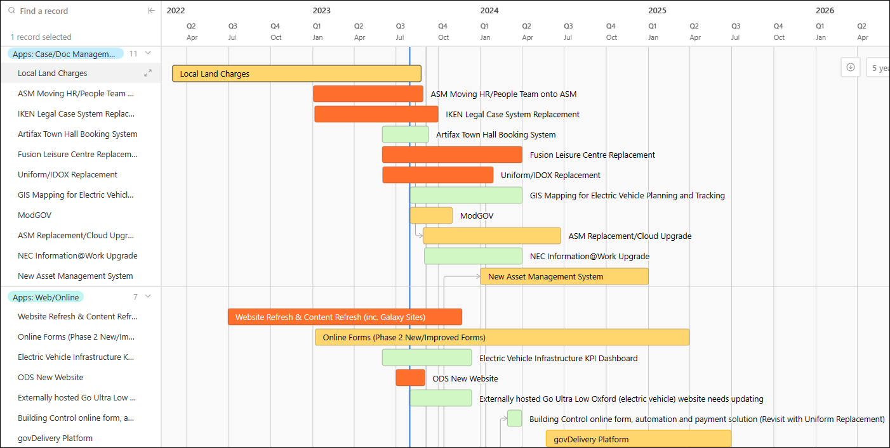

Appendix 2 – Projects by ICT Team and Priority (HML): Network and Comms

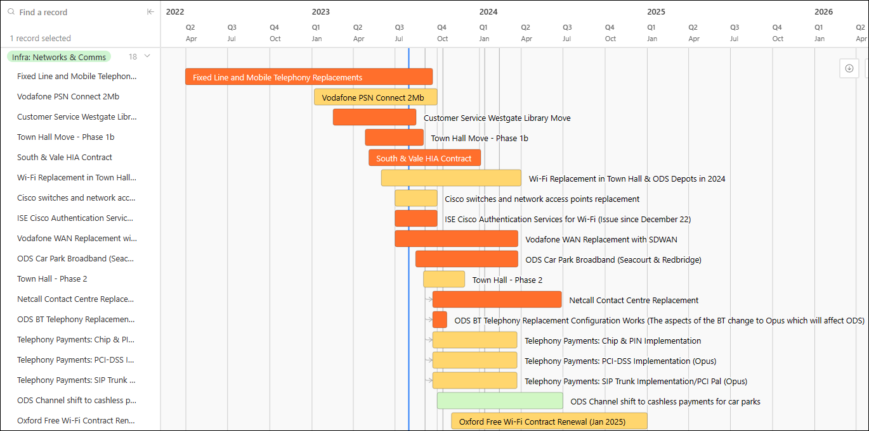

Appendix 2 – Projects by ICT Team and Priority (HML): Infrastructure, Security, Business Systems, Client Devices, Automation and Data
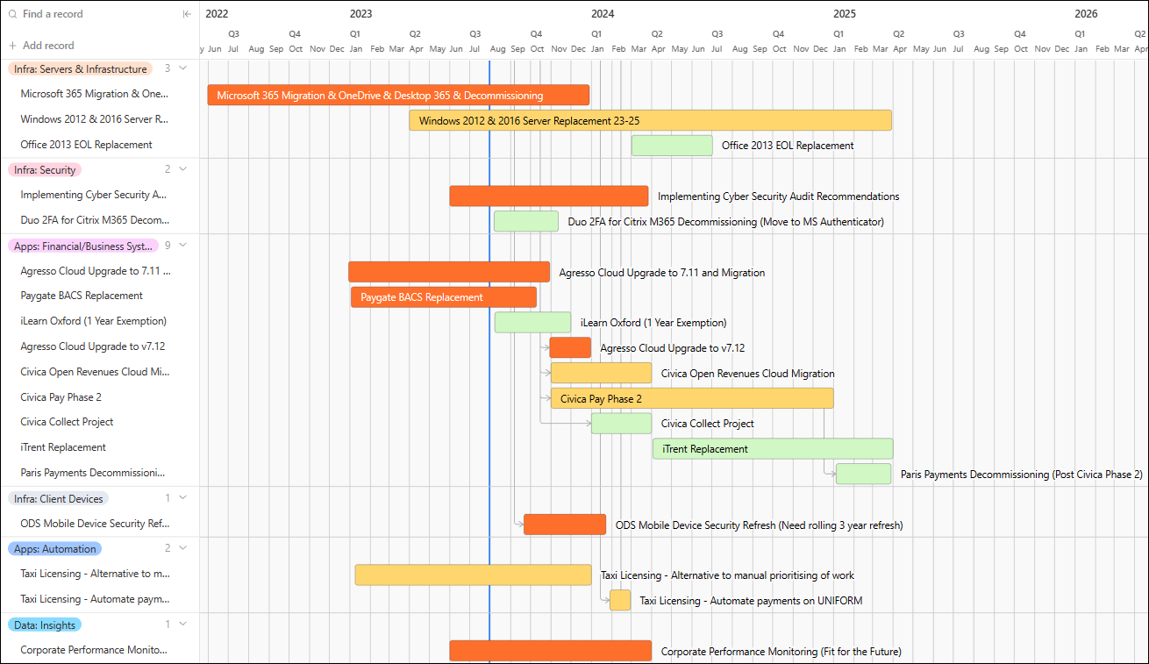

Appendix 3 – Projects with an impact on ODS
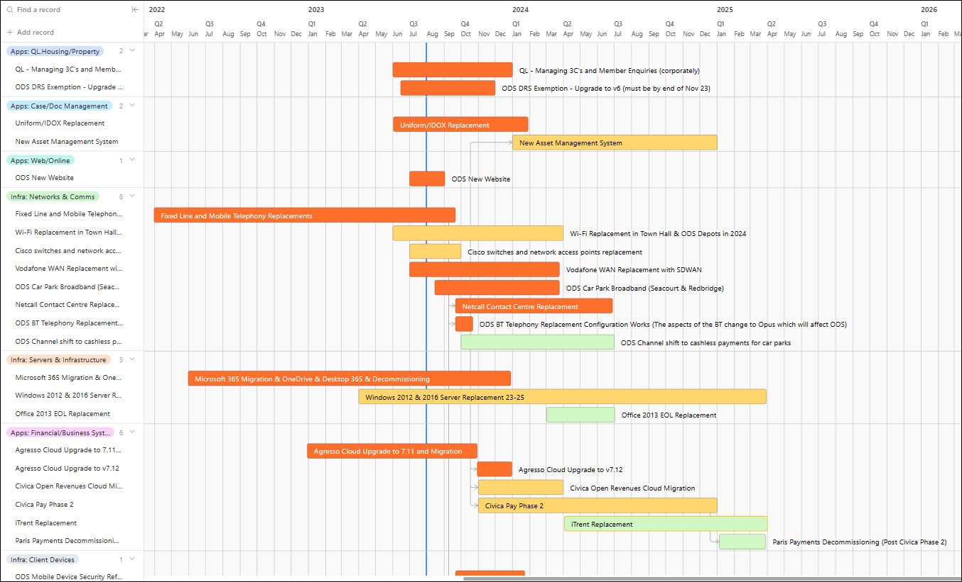
Appendix 4 – Projects with no start date identified
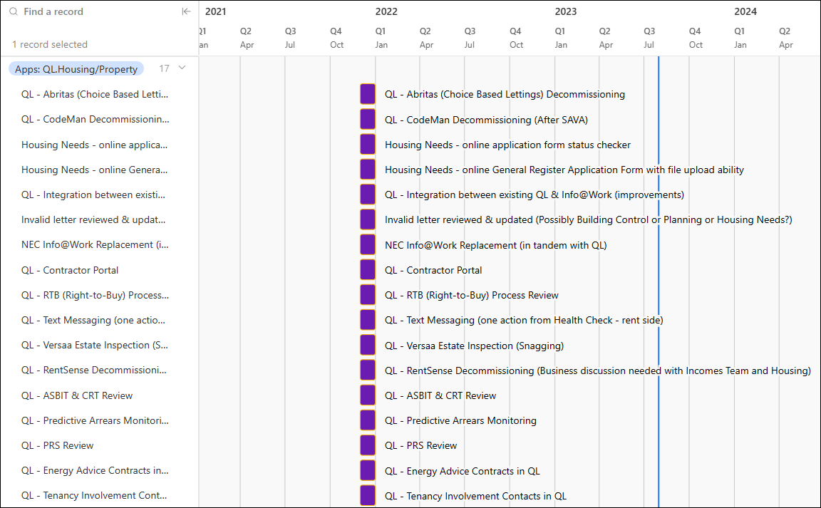
Appendix 4 – Projects with no start date (Page 2)
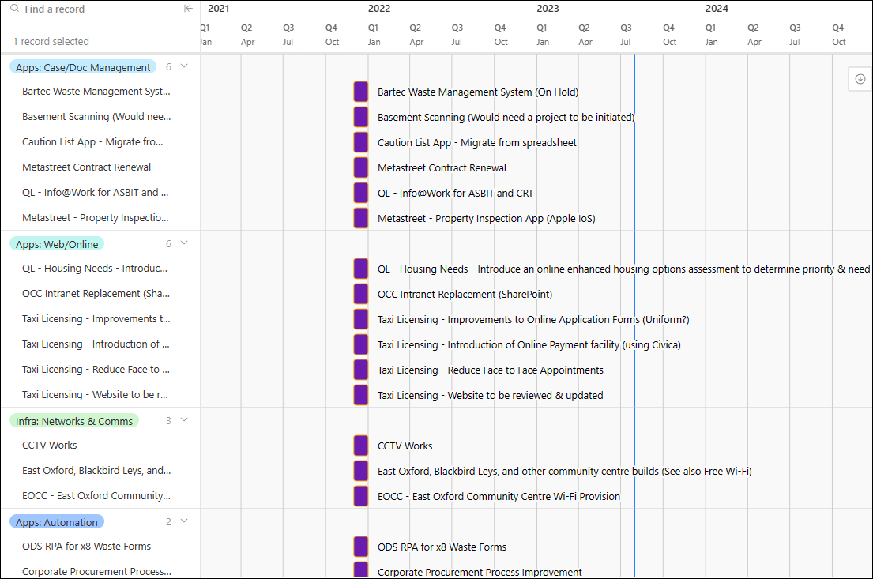

Appendix 5 Projects with funding not identified

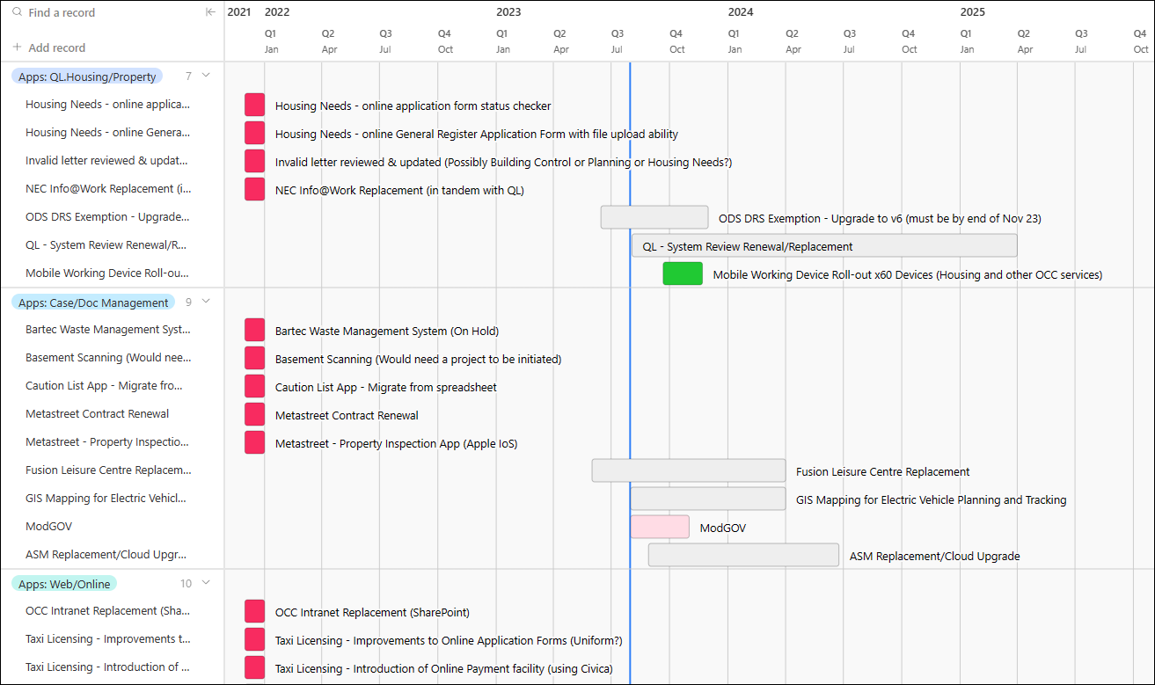
Appendix 5 – Projects with funding not identified (Page 2)
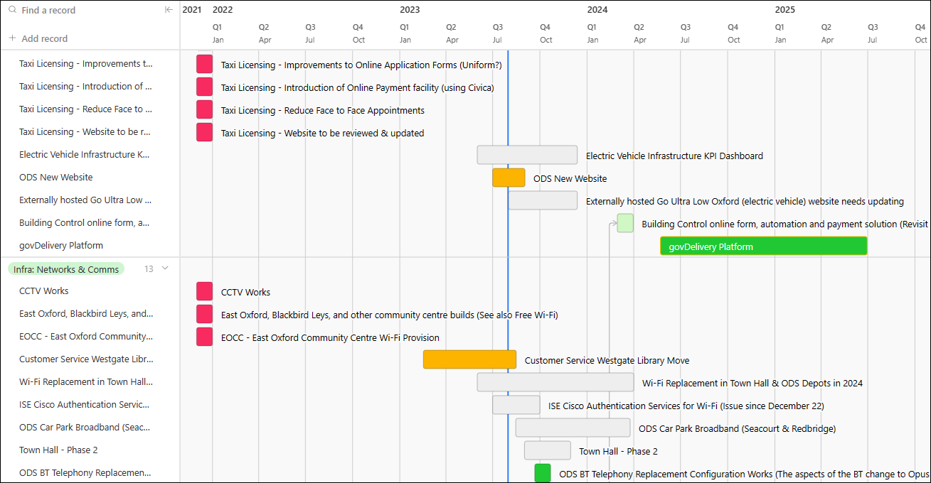

Appendix 5 – Projects with funding not identified (Page 3)
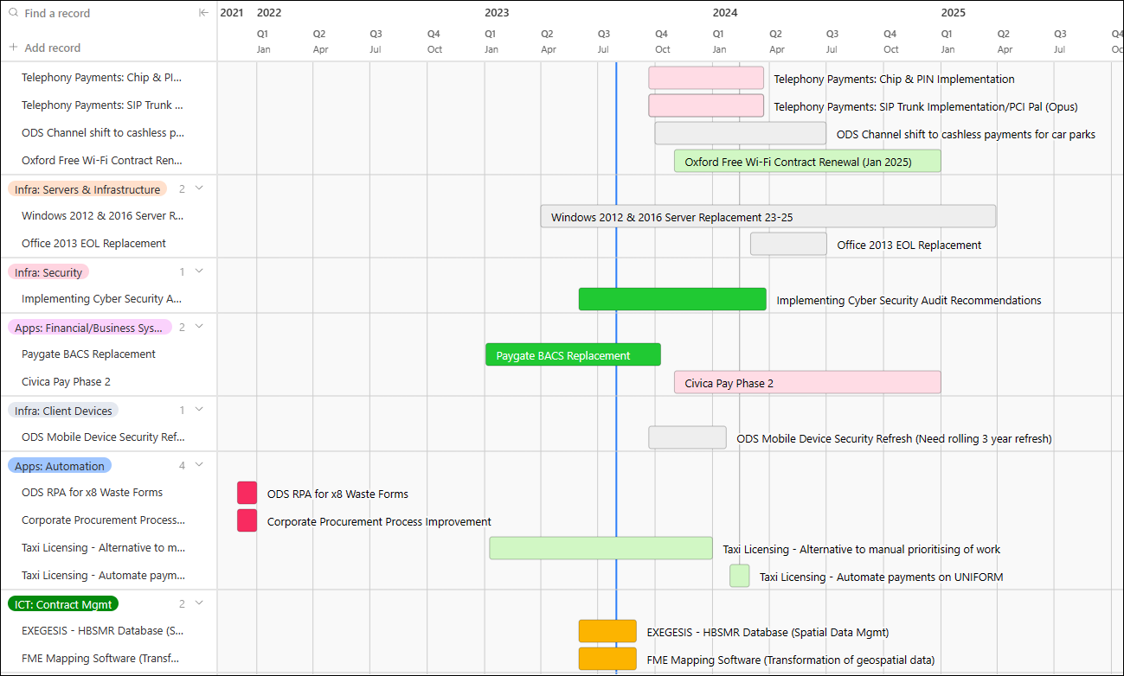

Appendix 6 – Criteria for differentiation small pieces of work from projects

From the perspective of ICT, the most common way of defining the difference between a small piece of work and a larger, more time-consuming task or project is based on the concept of effort, complexity, and resources required to complete the request. Small pieces of work would usually be submitted as a Service Request through ASM (vFire), with larger tasks going through the Front Door of Change. While there is no strict definition that universally applies, some common differentiators include:
1. Scope and Scale: A small piece of work typically has a well-defined and limited scope, while a larger task or project involves more extensive requirements and broader scope, potentially spanning multiple systems or departments.
2. Timeframe: Small tasks can usually be completed in a short timeframe, often measured in hours or a few days. In contrast, larger tasks or projects require weeks, months, or even longer to complete.
3. Resources Required: Smaller tasks often require fewer resources in terms of personnel, equipment, and budget, while larger projects necessitate significant resource allocation.
4. Complexity: Larger projects are generally more complex, involving multiple interrelated components, dependencies, and potential risks. Smaller tasks tend to be simpler and more straightforward.
5. Impact: The impact of a change request can also be a factor in determining its size. Larger projects often have a more significant impact on the Council's operations or infrastructure compared to smaller changes.
6. Degree of Planning and Coordination: Larger tasks or projects typically require more extensive planning, coordination, and collaboration among different teams or stakeholders.
7. Customisation vs. Standardisation: Smaller tasks may involve simple configurations or changes within existing systems or processes, while larger projects might involve custom development or substantial system redesigns.
8. Approval Process: The Council has different approval and review processes for small ICT changes (ASM/vFire) and large projects (Front Door of Change), with the latter requiring more thorough evaluations.

